

**River Emajõgi Network and Gauja Network Åland – Turku Archipelago program**

**11th May – 15th 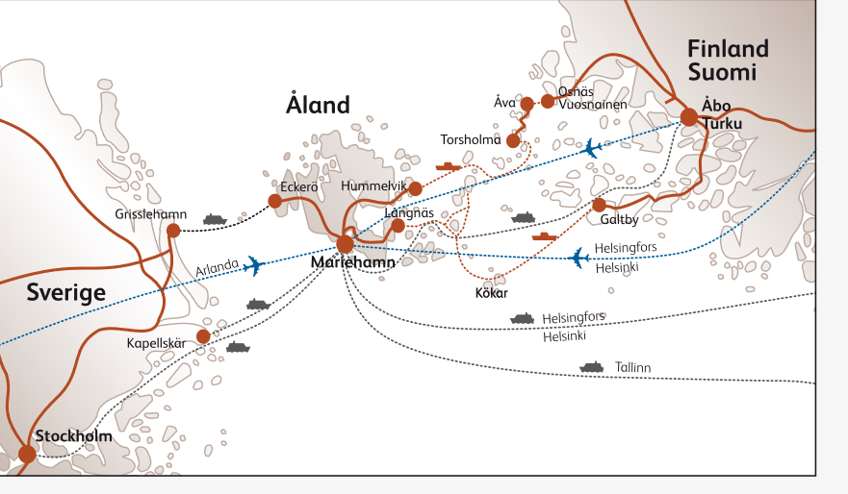May**

**Sunday, 11th May**

14:30 Departure from Tartu

18:00 Tallink D-terminal -> Åland Islands  
Dinner on the ferry

**Monday, 12th May, 2025**

4:50 Arrival at Åland Islands ([port of Mariehamn](https://mariehamnshamn.ax/en/))

7:00 Breafast at [**Hotel Arkipelag**](https://www.hotellarkipelag.ax/en)(Strandgatan 35, about 1,6 km)

9:00 Bus ride to [**Nabbens våtmark**](https://www.mariehamn.ax/trafik-och-miljo/vatmarker-och-dagvattendammar)(Elverksgatan 1, about 1,8 km)

Multifunctional wetland in Mariehamn, meeting with landscape architect **Johanna Hagström**

10:00 Walk to [**Sjökvarteret**](https://sjokvarteret.ax/)(Maritime Quarter) (Österleden 11, about 1,1 km)

Boatbuilding, a vibrant community life, and various artisans

Meeting with **Björn Kalm** (Leader Åland) and schooner **Emelia**

Free time in Sjökvarteret

enjoying the sea view and shoping at [SALT](https://www.saltshop.ax/) and [Guldviva](https://guldviva.com/en))

11:30 Bus to Langnäs (Järsö, about 13 km)

11:45 Boat trip to [**Stora Båtskär**](https://leader.ax/stora-batskar/)**,** old pilot station and meeting with Archipelago Pares and Lucas **Wideman**, guided tour, **David Ståhlman** (sportfishing organisation)

Lunch on island Stora Båtskär

15:00 Back with boat in Langnäs, Järsö

16:00 bus to [**Ålands Rural Centre**](https://landsbygd.ax/) (Jomalby, about 22 km) presentation with **Alexandra de Haas** (Executive Director Åland Leader)

17:15 Bus start to Långnäs Port 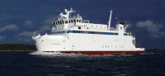(about 32 km)

18:15 Ferry to Kökar

Dinner on the **MS Skiftet**

20:45 Arrival at Kökar

Accommodation at [**Klobbars Gästhem**](https://klobbars.ax/)

Evening program on the island

**Tuesday, May 13, 2025**

**8:00 Brakfast at Guesthome**

**9:00 bus to** [**Bronze age village**](https://www.kokar.ax/otterboete) **(about 10 km) with Christian Pleijel (Senior advisor)**

**10:00 – 13:00 Presentation and workshob about ”Habitability Framework”**

**Lunch at Karlby Cafe (about 2,7 km) (local fish soup)**

**13:00 – 14:00 meeting with Olle Dahl** [**Karlby Cafe/Bakery**](https://www.facebook.com/p/Karlby-Café-100090477156043/)

**Bus to Kökar chuch (about 4,5 km)**

**14:15-15:30** [**Kökar church**](https://www.kokar.ax/st-annas-kyrka?lang=en) **and bird watching platform**

**bus to Kökar’s museum (about 9 km)**

**16:00 – 17:30** [**Kökar Heritage Association and museum**](https://kokar.hembygd.fi/startsida/) with **Anders Sundström**

**bus to ferry (about 8 km)**

**18:30 Departure from Kökar → ferry → Galtby**

**Dinner on the MS Viggen**

**20:45 arrival to Galtby**

**ferry to Nauvo**

**22:00 arrival to** [**hotel Strandbo**](https://www.strandbo.fi/hotel-strandbo.html)

**Wednesday, 14th May 2025**  
8:00 Breakfast at hotel

9:00 bus to [**Archipelago Center Korpoström**](https://skargardscentrum.fi/?lang=en) (about 32 km)

Presentation of the multifunctional Korpoström and the Archipelago Sea Area Biosphere Reserve

with **Katja Bonnevier** (coordinator of biosphere reserve)

Guiding in the Exhibition – Dive into the Archipelago Sea

Lunch at the Center

14:00 Bus to [**Paratiisi Art Center and Winery**](https://www.paratiisinagu.fi/english) (about 23 km)

Coffee break at the Center

16:00 Bus to Turku

17:30 arrival to Hotel Helmi Turku

18:00 walk trip to the center of Turku (with professor at Turku university **Pekka Niemelä**)

19:00 dinner at [**Hotel Helmi**](https://www.hotellihelmi.fi/en-gb/home?)

Free evening in Turku

**Thursday, May 15, 2025**

**8:00** Breakfast at the hotel

9:00 meetings with:

[**LAG Varsin Hyvä**](https://varsinhyva.fi/) (**Pia Poikonen**),

[**Keep the Archipelago tide**](https://keepthearchipelagotidy.fi/) (**Katariina Murto**)

[**Centre for Economic Development Transport and the Environment/Southwest Finland**](https://www.ely-keskus.fi/en/web/ely-en) **(Johanna Mattila)**

**Latvian and Estonian presentations**

12:00 Lunch in Turku in [restaurant Nooa](https://www.ravintolanooa.fi/en/)

13:00 Departure from Turku to Helsinki

16:30 Tallink ferry to Tallinn

Dinner on the ferry

18:30 Arrival in Tallinn

21:00 Arrival in Tartu

... 00:00 Arrival to Latvia

**Monday, May 12, 2025 PROGRAMME at Island Åland**

|  |  |
| --- | --- |
| **Nabbens våtmark** – Monday 12th at 9:00  The multifunctional wetland that has been created at Nabben in Mariehamn. The work on the wetland began in 2016 and 2017 when the City of Mariehamn participated in the Baltic Sea City Accelerator program. In 2017, the plan for the wetland was developed, and during the summer of 2019, the wetland at Nabben was completed. The project was planned by the City of Mariehamn in collaboration with the Environmental Office of the Åland Government. It has been largely funded by EU grants and contributions from the Baltic Sea Project. | [Video](https://www.youtube.com/watch?v=3whZPUbXfDg) about creating the multifunctional wetland  [Video](https://www.youtube.com/watch?v=xJux88M9kFM) about releasing pike fyr into wetland |

|  |  |
| --- | --- |
| **Sjökvarteret** – Monday 12th at 10:00  [The Maritime Quarter,](https://sjokvarteret.ax/) located in the eastern harbor of Mariehamn, is bustling with activities such as boatbuilding, a vibrant community life, and various artisans. Here you'll also find a seafarers' chapel, several museums, and during the summer, food and drinks. |  |

|  |  |
| --- | --- |
| **Schooner Emelia**  The schooner Emelia, just over 25 meters long, is currently being built in Åland. Emelia is being constructed in front of the public at the Maritime Quarter. According to the plans, the launch will take place in the summer of 2026.  [Facebook](https://www.facebook.com/Emeliabygget) of schooner Emelia |  |

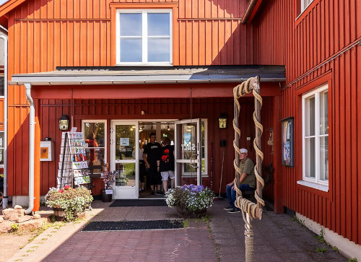

|  |  |  |
| --- | --- | --- |
| **Salt – a shop and studios**  You'll find handmade items in textile, silver, ceramics, glass, wood, and ironwork. There is always one of us artisans present in the shop. SALT is essential to life, and SALT adds flavor to everything. That’s how we want our crafts to be experienced.  **GULDVIVA a goldsmiths shop**  Founded 1989 as a traditional goldsmiths shop. Very soon it became apparent that GULDVIVA had the knowledge, the will and the ambition to create something more in place of just carrying out repair work and selling jewellery items produced by others. Head goldsmith Maria Karlström saw jewellery where no one else saw it. | |  |
| **Stora Båtskär Monday, 12th at 11:45**  The association Stora Båtskär rf, in close cooperation with Archipelago Pares rf, has decided to restore the pilot station on Stora Båtskär in the Nyhamn archipelago and create a new visitor destination focusing on cultural history in the outer archipelago, with an emphasis on the interaction between humans and nature. The first phase of the project is crucial for its implementation and involves restoring the several-hundred-year-old pilot harbor and, as soon as possible, renovating the exterior of the pilot station to make it weatherproof before the damage worsens.  **Archipelago Pares**  The association Stora Båtskär rf, in collaboration with Archipelago Pares rf, is restoring the pilot station on Stora Båtskär in the Nyhamn archipelago. The project aims to create a new cultural-historical visitor destination in the outer archipelago, emphasizing the interaction between humans and nature. The initial phase focuses on restoring the centuries-old pilot harbor and promptly renovating the pilot station's exterior to prevent further damage. The project is supported by the Åland Islands' Rural Development Program and the European Agricultural Fund for Rural Development. |  | |

|  |  |
| --- | --- |
| **Ålands Rural Centrum Monday, 12th at 16:00**  In the heart of the Åland rural landscape at Jomala Farm, fifteen organizations are gathered under the same roof – all sharing the common vision of developing and diversifying business activities in the countryside. With our combined knowledge and strong commitment, we work together to inspire and support profitable entrepreneurship in the Åland countryside. |  |

**Tuesday, May 13, 2025 PRGOGRAMME at Island Kökar**

|  |  |
| --- | --- |
| [**Otterböde Bronze age village**](https://www.kokar.ax/otterboete?lang=en)  At the bottom of the Otterböte hill, there is a unique settlement of seal hunters from the early Bronze Age (about 900 BC). It consists of the remains of nine round huts, several rubbish heaps and a little well. You'll get to Otterböte through a 600 m long footpath from Hamnövägen. Sturdy shoes are recommended.  Otterböte was populated by seal hunters from the south, who came north for seal hunting in springtime. We know this due to numerous findings of potsherds found during excavations. The clay of these potsherds comes from the southern shores of the Baltic Sea; northern Poland and the island of Bornholm. The walls of the vessels also have imprints of cultivated plants, showing that they have been manufactured in an agricultural environment. |  |

|  |  |
| --- | --- |
| **“Habitability Framework” – workshop**  How livable are we? That is a question all archipelago municipalities in Åland should consider in order to plan for the future. “Habitability” is a method for a broad and inclusive analysis of the attractiveness of an island community. It can be described as a simplified sustainability analysis that focuses on whether an island is “habitable” — that is, whether there are housing, jobs, schools, shops, transportation, and social services available.  Habitability does not conflict with sustainability, but a small island community must first be livable. If the island cannot maintain a vibrant population of all ages, it is not a sustainable society. Until now, such an analytical tool has been missing. |  |
| There are few examples of local development plans for islands that are based on an honest self-assessment. Tools developed to measure attractiveness are generally designed for cities and rural areas, but they do not work well on islands due to their unique characteristics. |

|  |  |
| --- | --- |
| [**Karlby Cafe and Bakery**](https://www.facebook.com/p/Karlby-Café-100090477156043/)  Owned by Olle Dahl -  recently opened café in the center of Kökar, next to the store. It sells Kökar mustard, which won a gold medal at the 2023 World Mustard Championship! He is also the contact person about the project that these had together:  Finnö, Österbygge and Öfverboda |  |

|  |  |
| --- | --- |
| [**Kökar chuch**](https://www.kokar.ax/st-annas-kyrka?lang=en)  Situated at Hamnö, is dedicated to Anna, grandmother of Jesus. The current stone church was inaugurated in 1784 and is built on the remnants of the old monastery church. The look of the church has not changed in two hundred years, only the sacristy was added in 1876. Inside, the most important change is the organ loft inaugurated in 1912. The organ was in use until 1992 when the current organ was installed. The old organ can now be seen at the Kökar museum. |  |

|  |  |
| --- | --- |
| [**Kökar Heritage Association and museum**](https://kokar.hembygd.fi/startsida/)  was founded in 1988. The same year, the Kökar Museum was also opened, housed in the former Hellsö-Österbygge village school. The area around the museum includes several different buildings, such as a machine hall with old engines, a boat hall, a ceramics workshop, a blacksmith's forge, and a log house built in the traditional Kökar style.  Kökar Heritage Association r.f. has, through its work with the museum, collected and preserved thousands of objects that showcase Kökar’s unique cultural heritage. The items and photographs tell the story of Kökar’s history and the living conditions of its people from the Bronze Age to the present day. |  |

**Wednesday, 14th May 2025 PROGRAMME**

|  |  |
| --- | --- |
| [**Archipelago Center Korpoström**](https://skargardscentrum.fi/?lang=en)  Archipelago Center Korpoström is a versatile visitor center located on the island of Korppoo, in the Turunmaa archipelago. Our archipelago center is aimed at tourists of all ages, as well as local residents who want to enjoy the wonderful nature, relax by the sea and participate in many different activities.  **Main Exhibition:** dive deeper into the Archipelago Sea, and explore its history, the landscape and life unfolding beneath the surface, and learn more about the research being conducted about our sea. The exhibition also features works of art by artists who have stayed at the ProArtbus residency in Korpoström. |  |

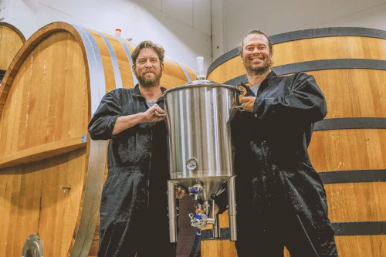

|  |  |
| --- | --- |
| [**Paratiisi (Paradice) Art Centre and Winery**](https://www.paratiisinagu.fi/english)  Finland’s largest art center in the Archipelago Sea in Nagu. We are now seeking artists for the summer 2025 art exhibition.  **Haapman Estate** is Finland's first commercial winery where Cabernet Sauvignon, Pinot Noir, Merlot, Chardonnay and Riesling grow. |  |

### Åland – A Peaceful Archipelago in the Baltic Sea

|  |  |
| --- | --- |
| Åland is an autonomous region of Finland. It is located in the Baltic Sea, between Finland and Sweden, and consists of over 6,500 islands, about 60 of which are inhabited. The capital is Mariehamn, where most of the region's population lives.  The only official language of Åland is Swedish, even though it is part of a Finnish-speaking country. Most of the residents speak Swedish as their mother tongue.  Åland’s economy is mainly based on shipping, tourism, agriculture, and the food industry. The region has its own postal service and license plates. Taxation differs slightly from the rest of Finland, and Åland is not part of the EU customs territory, which affects ferry travel and duty-free shopping. |  |

### Turku Archipelago – The Southern Jewel of Finland

|  |  |
| --- | --- |
| The Turku Archipelago is located in Southwest Finland and consists of thousands of islands stretching from the city of Turku all the way to Åland. It is one of the largest archipelagos in the world and is known for its natural beauty, maritime lifestyle, and peaceful atmosphere.  The Turku Archipelago has been inhabited since the Stone Age. During the Middle Ages, it was an important part of the trade route between Sweden and Finland. Many islands served as ports, fishing villages emerged, and the area saw active maritime traffic. During the time of the Swedish-Finnish union, the archipelago belonged to the important administrative and ecclesiastical center of Turku. |  |